Jenkinsfile

Jenkinsfile is **a text file that contains the definition of a Jenkins Pipeline and is checked into source control**. Consider the following Pipeline which implements a basic three-stage continuous delivery pipeline. Jenkinsfile (Declarative Pipeline)

Create a file called as Jenkins file and paste the Pipeline code into it in the git repository where the code has been present .

Webhooks

===========

This is used to send notifications from github to Jenkins

Whenever any code changes are done and that is checking into

github, webhook will send an immediate notification to Jenkins

and Jenkins will trigger the job

1 Open github.com---->Click on the repository that we are working on

2 On the right corner click on Setting

3 Click on Webhooks in the left panel

4 Click on Add Webhook

5 In Payload URL: http://public _ip of_jenkinsserver:8080/github-webhook/

6 In Content type select :application/json

7 Click on Add Webhook

8 Open the dashboard of Jenkins

9 Go to the job that we want to configure

10 Go to Build triggers

11 Check GitHub hook trigger for GitScm polling

12 Click on Apply--->Save

Now if we make any changes to the code in github then github

will send an notification to Jenkins and Jenkins will run that job

Multibranch pipeline

Multibranch pipeline : A multibranch job is simply a folder of pipeline jobs. For every branch you have, Jenkins will create a folder. So instead of creating a pipeline job for each of the branches you have in a git repository.

Generally developers create multiple branches and upload

code related to various functionalities on these branches

We have to configure Jenkins in such a way that it triggers

CI-CD process for all these branches parallelly.

To do this we need to have a copy of Jenkins file on each branch

and then based on the instructions in the Jenkins file all

the stages have to be triggered

Create multibranch pipeline

1. Click item
2. Enter the item name
3. Click multibranch pipeline
4. Click ok button

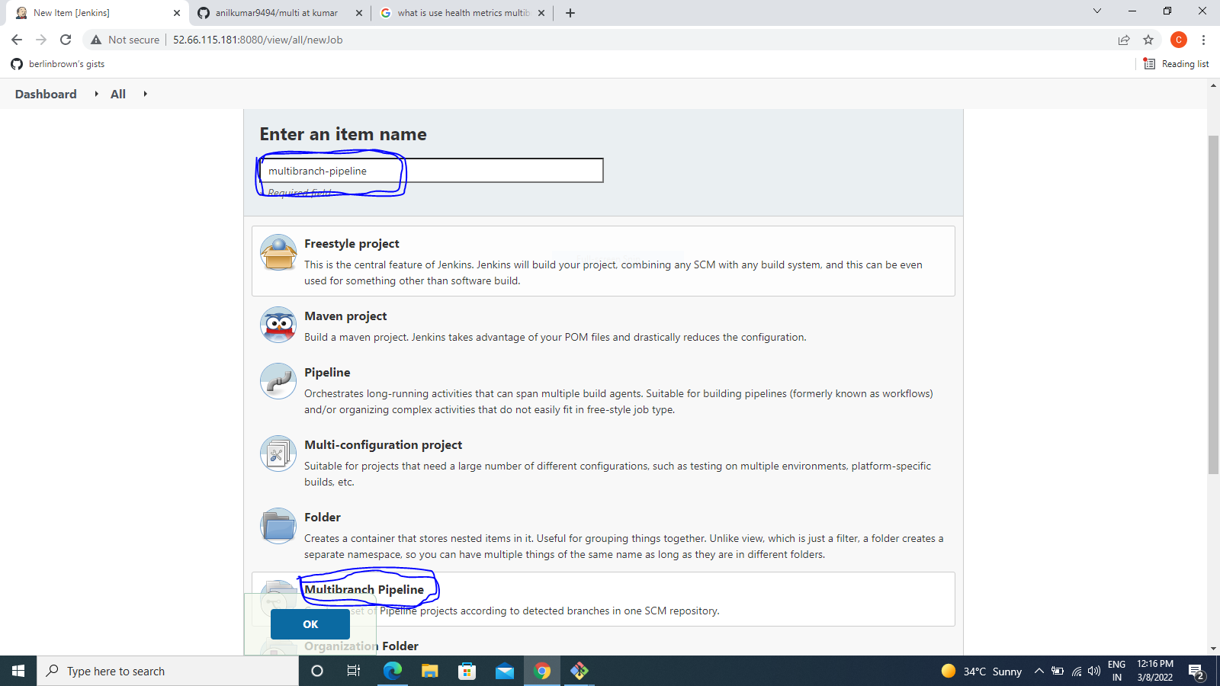

* Display
* Description
* Go to branch sources
* Select github
* Add credtional if you have

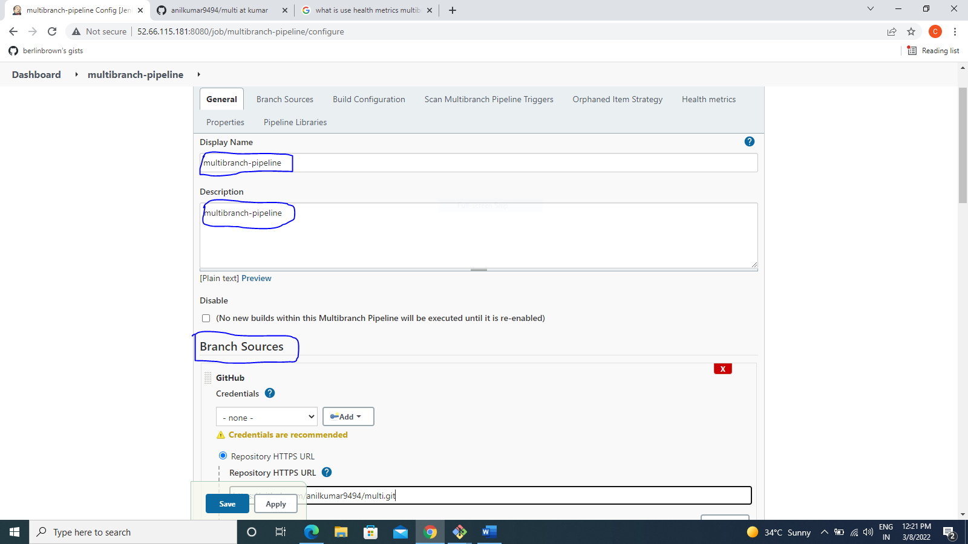

* Your repositories(github your create multi branches repository) url copy and paste the Jenkins jobs

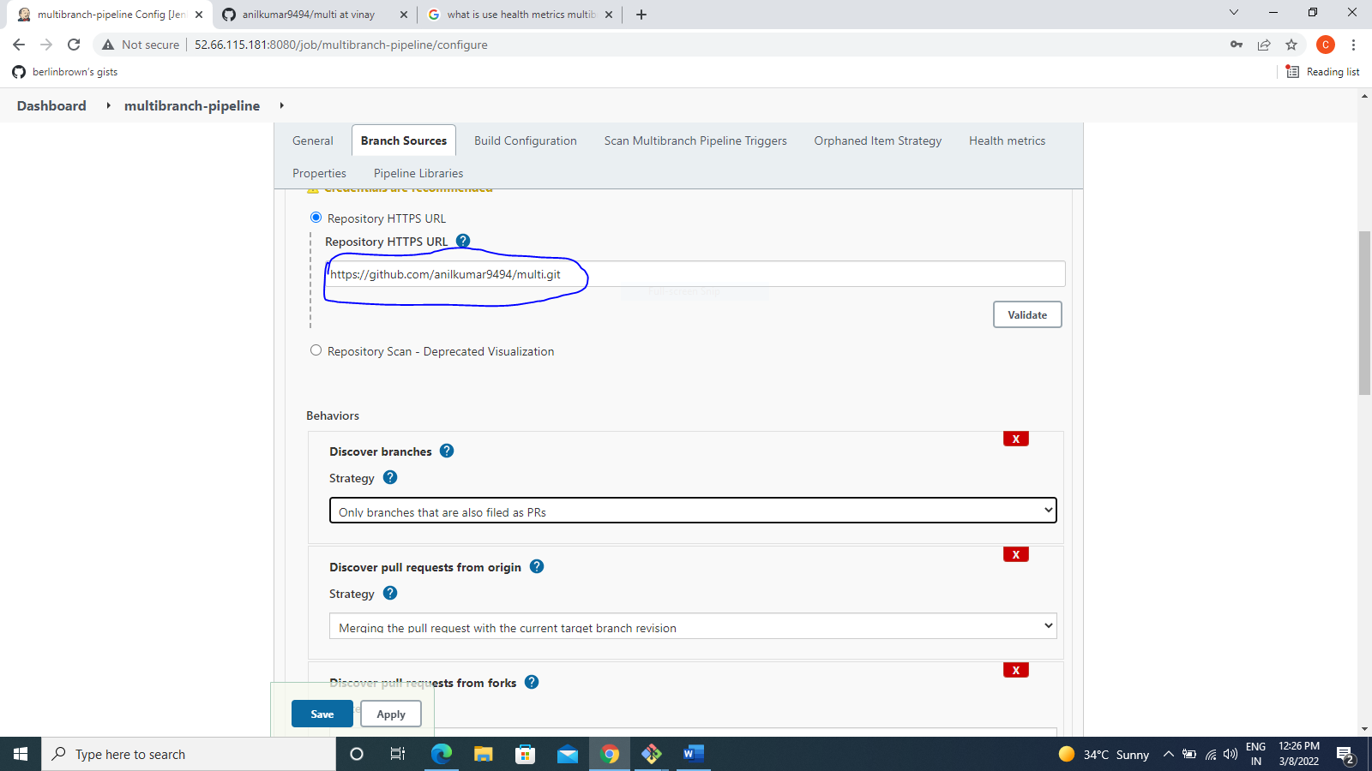

* Your Jenkins file name

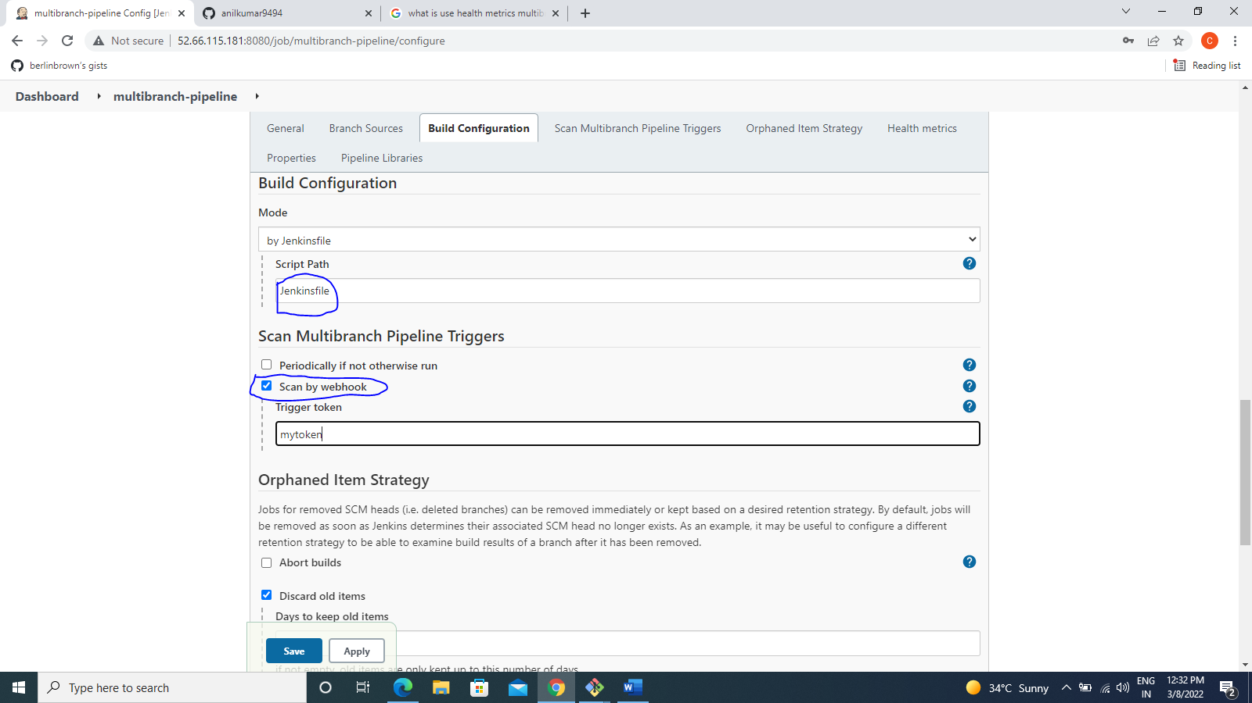

* Click Apply
* Click save

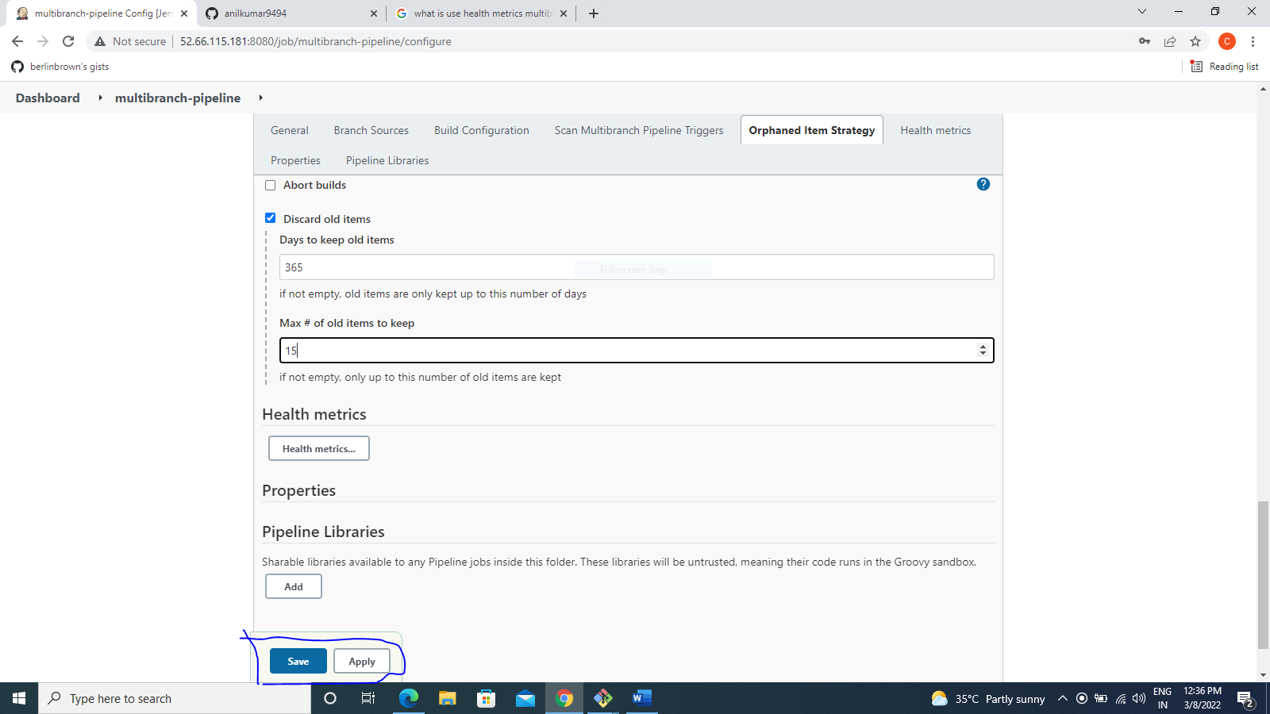

* Go to dashboard
* Click your job multibranch-pipeline

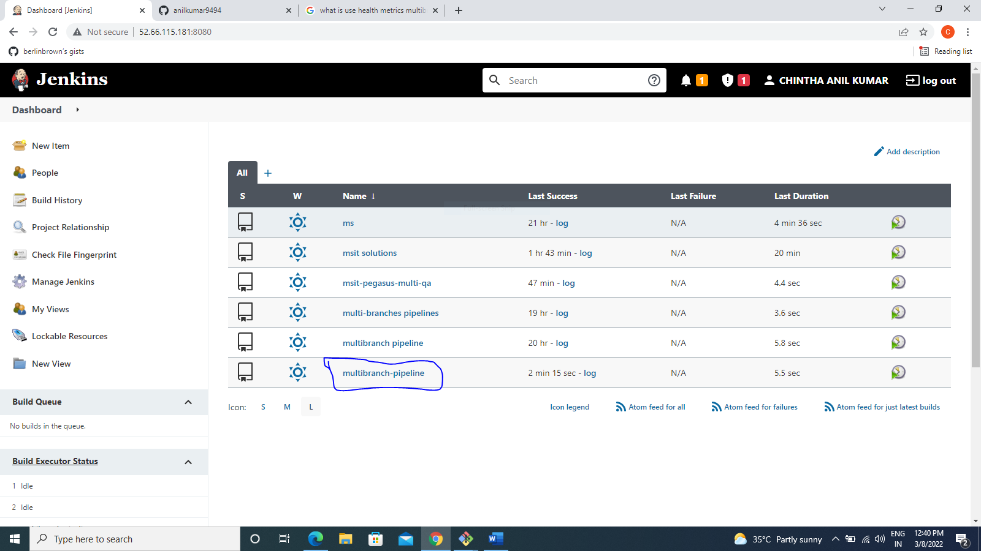

* Your branch,pull requests
* Click branch name

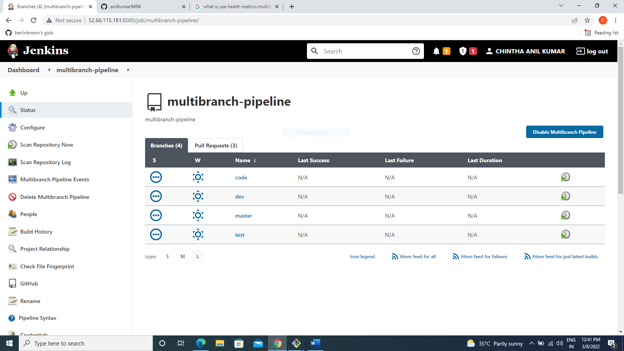

* Show build ,test ,deploy stages

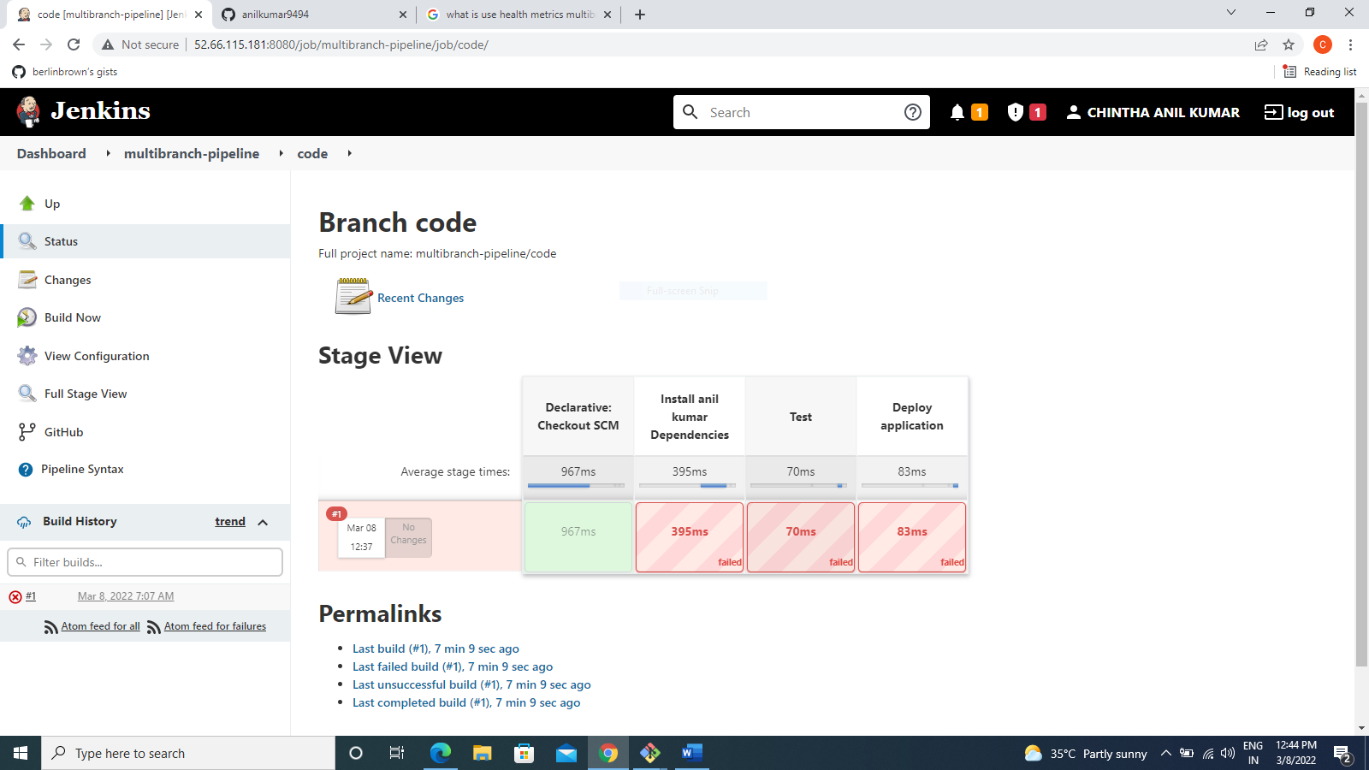

* Click scan repository now

